Weekend Field Trip to St. Andrews State Park

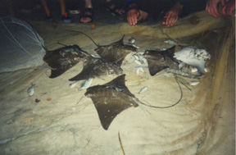
Our weekend field trip to Florida promises to be loads of fun, but also requires lots of planning. We will try to leave campus as close to 1 p.m. on Friday as possible for the 6 hour drive to Panama City Beach. If any of you can show up early to help us pack, this will help to keep us on schedule. You should have lunch before we leave and bring some cash for dinners on the road on Friday and Sunday evenings.
When we arrive at St. Andrews State Park (hopefully around 8 p.m.), we will immediately set up camp. We will then head out to the beach for some fabulous night seining. On past trips, we have observed lots of rays and lumnescent organisms in the water. It generally is cool in the evening, so you should consider bringing a wetsuit or some kind of windbreaker to use while we are in the water.

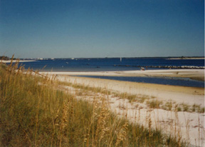
After breakfast the next morning, we will form seining teams to seine in St. Andrews Bay. I will bring a small boat and a trawl and will take turns taking students out trawling in deeper water. We will return to camp at midday for lunch. Afterwards lunch, we will set out to the Gulf side of the park for snorkling and fishing on rock jetties lining the outlet to St. Andrews Bay. The jetties are famous for attracting a variety of reef fishes and invertebrates. You should bring a mask and snorkle. If you don't own this equipment, it is possible to rent it in the park.

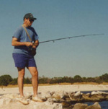
You should also bring fishing gear, if you fish, but bring some extra money to purchase a fishing license (about $10).

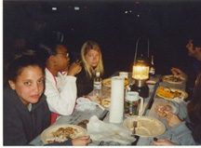
We will return to camp around 5 p.m. to start preparing dinner. Those who are not on the dinner crew can use this down time to check out some of the fishes we have collected to this point. Dinner is generally a long drawn-out process, but we should finish early enough to do a little night trawling or perhaps some more beach seining.

We will break camp around 10a.m. Sunday morning, and start the drive back to New Orleans. One the way back, we will stop at a site on the Pascagoula River to seine and electrofish for gar, bowfin and other large-river fishes. Depending on when we leave this site, we may stop for dinner on the road.

A trip with this much activity requires a lot of planning, and we will all have responsibilities. I will collect $20.00 from each of you for meals and other needed supplies. I will divide the class into three groups for the five meals that have to be planned/prepared: breakfast and lunch on Saturday; dinner Saturday night; breakfast and lunch on Sunday. Duties will include preparing and serving assigned meals, and cleaning up afterwards. Each group is responsible for deciding what to prepare and making sure we have enough food and the necessary cookware, utensils and serving supplies (we have a pretty good collection of pots and pans, a stove, serving spoons, plates, forks, knives, spoons, cups, etc). Simple meals like spagetti with sauce, salad and bread, and continental breakfast are better than elaborate meals that require plenty of preparation time. Lunch should be sandwiches, chips and fruit that we can eat on the go. All meals should include drinks, AND BREAKFAST MUST INCLUDE COFFEE!

I will give you the final count of how many people you have to prepare for and whether there are any diet restrictions. A representative of each group will be given an allotment of the money I collect for purchasing the group's food. Any money not spent on supplies will go into a general fund to cover any needs that arise during the trip. Groups are advised to get together early to plan their meals and needs as far as cooler space. I would like to know what you are planning a week before the trip. To ensure freshness, food should be purchased and delivered to the lab during the week of the trip (we have a refrigerator for storage of perishable items).

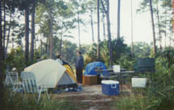
We will be tent camping. I will take inventory of who has tents and sleeping bags to ensure that we have enough. You should bring a sweater in case the weather turns cool in the evening, something to get wet in (including shoes), dry shoes and at least three changes of clothes. Also bring a flashlight or headlamp, insect repellent, and sun screen.

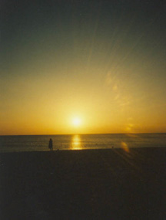
Again, this promises to be an eventful and interesting trip. Our objective is to see representatives of as many groups of the fishes you are learning in lab as we can, and to gain an appreciation for the habitats these fishes live in.

